025:250 COMPOSITION: ELECTRONIC MEDIA I

Fall 2015

Assignment 1

Due Sept. 9

1. This assignment will be presented in a Pro Tools session in class Sept. 9-13.

2. Meet with Jonathan and Jonah to set up a Pro Tools session and import some Soundmine files. There are 24 of these. Each student in class is assigned the three files shown below. Please decide on a way to choose right now.

Student 1 | Wood 1 | Rubber | Balls3
Student 2 | Wood2 | Balls2 | Cardboard3
Student 3 | Scissors | Books | Grains
Student 4 | Balloons | Cardboard2 | PaperBags
Student 5 | Cardboard1 | Shakers | MechanicalMetals
Student 6 | Balls1 | Fabric | PackingCardboard
Student 7 | Combs | SmallMetals | Paper&Cardboard
Student 8 | RubberBands | Swooshes | PlasticBottles

3. Jonathan and Jonah will help you import the files in your session, place them in Track 1, and remove all silences.
This will give you individual regions for each sound of a given file.

4. The steps below describe a method for creating gestures out of these regions, beginning with a process called

cherry picking.

Step 1. Cherry pick the desired regions from Track 1 and drag them down to Track 2, as shown below.

Step 2. Gather the up the regions in Track 2 by dragging them close to each other, as shown below.
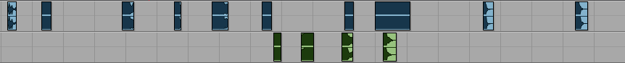

Repeat Step 1 with other regions.

Repeat Step 2 by gathering up the regions in Track 2.

Step 3. Zoom out so that you can see both sets of regions in Track 2, as shown below.

Step 4. Drag the set on the right so that it joins up with the set on the left, as shown below.

Step 5. Drag the combined sets to near the beginning of the Edit Window, as shown below. Notice that these
have been moved to Track 1.
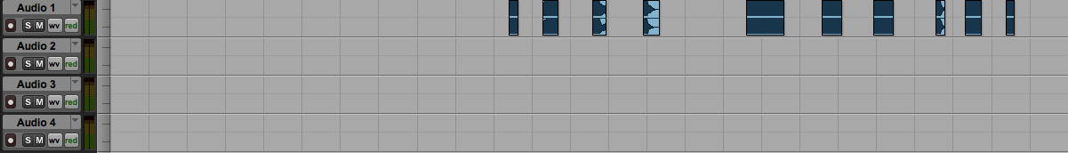

Step 6. Drag each region to its own track. Position them in time to produce a single, unified gesture, as shown
below in the left image. Notice that there are 10 regions sounding within less than 2 seconds.
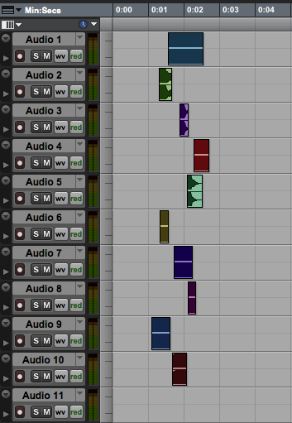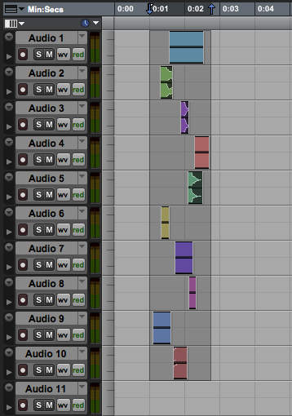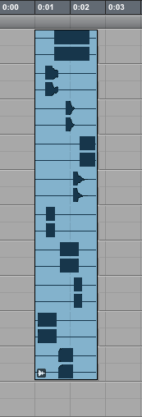

Step 7. Highlight the regions as shown above in the middle image.

Step 8. Go to the Region menu and select Group. You should learn the key command opt cmd G. The group is
shown above in the right image.

Step 9. Double click on the group and a window like the one below on the left will appear.
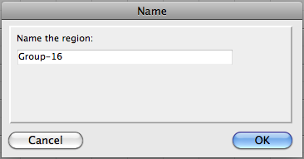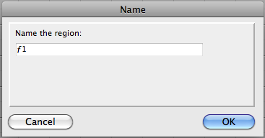

Step 10. Name the group ƒ1, as shown in the image above on the right. The symbol ƒ is created by typing opt f.
This is not very important, but it makes the game a little more fun/OCD. More importantly, the symbol ƒ shows
up very well in a list. Furthermore, an entity designated ƒ is seen as a different kind of object that is a collection
of other objects. Other aspects of this will be discussed in class.

5. Shown below are two other groups. Unlike the group ƒ1, described above, the group on the left has all of the
regions sounding together. This can be thought of as a tighter version of ƒ1. The group on the right has every
region beginning at exactly the same time. This is an even tighter version ƒ1.

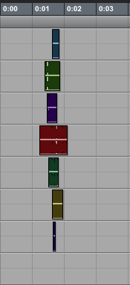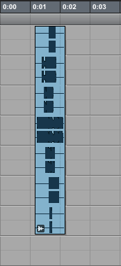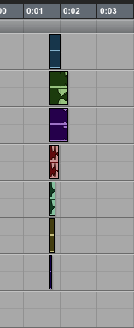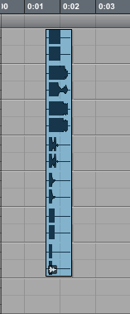

6. You should make 15 groups of each type described above. The first type will use regions that occur at different
times, but within a window of no more than 3 seconds. Most of them should be between 1.5 and 2.0 seconds
long. The second type will use regions that are arranged in a tighter configuration, and which generally all sound
at the sound time, but with individual start times. The third type is a chord, in which all of the regions start
exactly at the same time. They will naturally end at different times, but that is part of the beauty of this type of
gesture.

7. Other possibilities and considerations will be discussed in class.

